Title page

**Optimizing Strategic Decisions in Formula 1 Q3 Qualifying**

Uma Bhat, Media & Journalism B.A. & Statistics Minor

Asher Cohn, Economics B.A. & Statistics Minor

Sawyer Fotheringham, Statistics B.S. & Sport Administration B.A.

Philip Garside, Chemistry B.A. & Statistics Minor

Rhett Lavender, Data Science B.S.

Abisai Lujan, Statistics B.S. & Information Science B.S.

STOR 538 - Group 2

Department of Statistics and Operations Research

University of North Carolina at Chapel Hill

**INTRODUCTION**

Our analysis focuses on the popular international motorsport, Formula 1–the highest class of international racing for single-seater cars. It is a team sport, with two drivers assigned to a team. Ten teams participate in a thrilling annual competition that attracts fans around the world, where success is often determined by mere seconds. To gain a competitive edge, they field different motorsport models and strategic driving decisions to maximize performance and achieve success.

The championship entails 24 consecutive race weekends composed of practice sessions, qualifying, and the Grand Prix. Each weekend’s track varies in location, layout, and conditions. Following the practice sessions, drivers compete in qualifying sessions to determine the grid position (i.e., starting position) of the drivers in the Grand Prix. The Grand Prix serves as the main event of each weekend and ultimately determines the championship winner.

The competition follows a points-based system, where for each Grand Prix, only the top ten drivers earn points. More points are awarded for higher finishing positions. Intuitively, drivers at the front of the starting grid hold a strong advantage; maintaining their position or taking the lead further increases their likelihood of earning the most points.

Success in the Grand Prix often depends on securing the best grid positions, making qualifying strategy the key focus of our analysis. We will observe any relationships between qualifying decisions (e.g., number of laps attempted, timing of lap entries, response to track conditions) and the Grand Prix starting grid position. Also, we hope to identify other helpful performance and condition metrics that may increase the chances of earning points and ultimately winning the championship. Research by Spolaor supports this focus, demonstrating that strategic choices during qualifying (e.g., lap timing, tire selection, and managing risks of yellow or red flags) significantly influence drivers’ starting positions and Grand Prix outcomes.

The qualifying sessions allow drivers multiple attempts to complete a hot lap. Qualifying consists of three sessions: Q1, Q2, and Q3. In Q1, all 20 drivers have 18 minutes to set lap times, with the fastest 15 moving onto Q2, and the bottom five grid positions are locked into place for the Grand Prix. Q2 follows the same format, reduced to 15 minutes, with the top ten drivers moving onto Q3, and the next five grid positions are set. Finally, the ten drivers in Q3 have 12 minutes to secure the fastest hot lap and best grid position to compete in the Grand Prix.

Attempts to set the fastest lap times are commonly referred to as hot laps. However, before drivers attempt this, they first do one or two out laps once they leave the pit (i.e., warm-up laps). With speeds during a hot lap exceeding 200 miles per hour, these slower out laps allow drivers to safely heat engines, tires, and track for an optimal hot lap. Higher track temperature is important for optimal tire grip and performance. A hot lap is a complete round about the track in which a driver attempts to set the fastest time possible–a time that will count toward their ultimate placement in the following Grand Prix.

We chose to focus our data collection on Q3, as this encompasses the largest sample size of drivers attempting to set the fastest lap possible. In Q1 and Q2, the fastest teams often do not have to deploy their best strategy because, for the top ten drivers, these sessions do not directly set their grid positions. This could lead to a discrepancy when analyzing strategic decision making, so by focusing our data and analysis only on Q3, we can isolate more consistent results.

Past research into Formula 1 has focused on issues like the build of a car’s impact on outcomes, economic approaches to evaluating Formula 1 talent, and differences in driving strategy, among other things. Our analysis is unique because it focuses on data specific to the qualifying race before a Grand Prix, and because we collected unique variables not officially collected by Formula 1.

*Data preview*

| Driver Name | Team | Attempted Hot Lap Number (1 or 2) | Time Remaining in Session at start of Outlap (Seconds) | Number of Outlaps | Amount of Drivers on Track at start of Hot Lap |
| --- | --- | --- | --- | --- | --- |
| VERSTAPPEN | Red Bull | 1 | 678 | 1 | 8 |
| VERSTAPPEN | Red Bull | 2 | 162 | 1 | 8 |
| LECLERC | Ferrari | 1 | 641 | 1 | 8 |
| LECLERC | Ferrari | 2 | 151 | 1 | 8 |
| RUSSELL | Mercedes | 1 | 687 | 1 | 8 |
| RUSSELL | Mercedes | 2 | 183 | 1 | 8 |
| SAINZ | Ferrari | 1 | 651 | 1 | 8 |
| SAINZ | Ferrari | 2 | 144 | 1 | 8 |

The above table shows seven columns from our dataset. **Driver Name**, and **Team** were non-observational variables collected at the start of the session, while **Teammate in Q3, Attempted Hot Lap Number (1 or 2), Time Remaining in Session at start of Outlap (Seconds), Number of Outlaps, and Amount of Drivers on Track at Start of Hot Lap** were all observational variables. These were collected alongside nine other observational variables.

*Collection of data*

To collect the data for this project, we purchased a month-long subscription to F1 TV, the official streaming platform of Formula 1. Using F1 TV’s archive feature, we accessed full replays of each Q3 qualifying session from the 2024 F1 season. Throughout each session, we utilized the live data tab available during broadcasts, which provides real-time information on driver sector times, lap lengths, tire choices, weather conditions, and track temperatures.

The data collection process took place from April 8 to April 11, with each group member being assigned four Q3 qualifying sessions to observe. We manually recorded the data in a Google Sheets file as each qualifying session unfolded, ensuring that each driver’s sector-by-sector performance, hot lap attempts, and track context were captured accurately. In cases where a red flag interrupted the session—cutting a hot lap short due to a crash or incident—we discarded those incomplete laps to maintain consistency across the dataset. This approach allowed us to build a comprehensive dataset that reflected raw lap performance and the strategic and environmental factors that influence qualifying outcomes.

*Description of data*

Our dataset contains 428 samples, each representing decision, performance, and condition metrics for each hot lap an individual driver attempted in every Q3 Qualifying session for the entire 2024 season. Below are formal definitions of what each feature represents:

`Name of Track` - The name of the racing circuit where the event was held.

`Driver Name` - The name of the driver attempting the hot lap.

`Team` - The constructor (team) that the driver races for.

`Teammate in Q3` (Binary Y/N)- Is this driver’s teammate also participating in the Q3 race?

`Attempted Hot Lap Number` (1 or 2)- Whether this was the driver's first or second hotlap attempt during the Q3 session.

`Time Remaining in Session at start of Outlap (Seconds)`- How much time was left in the Q3 session (in seconds) when the driver began their outlap before the hot lap.

`Number of Outlaps`- The number of out laps the driver completed before starting their hotlap attempt.

`Amount of Drivers on Track at start of Hot Lap`- The number of other drivers already on track when the driver began their hot lap attempt.

`Track Temperature at start of Hotlap` - The track surface temperature (in °C) at the moment the driver began their hot lap.

`Weather at start of Hot Lap` - The observed weather condition at the start of the hot lap.

`Tire type during hot lap` - The compound of tires used during the hot lap (e.g., Soft "S", Medium "M", Hard "H").

`Sector 1 Time` - The driver’s time to complete the first sector of the track (in seconds).

`Sector 2 Time` - The driver’s time to complete the second sector of the track (in seconds).

`Sector 3 Time` - The driver’s time to complete the third sector of the track (in seconds).

`Length of Hotlap Attempt` - Total duration of the hot lap (in seconds).

`Position after Lap` - The driver’s provisional ranking immediately after completing the hot lap (can be temporary).

`Position after Session End` - The driver's final position at the conclusion of the Q3 session (e.g., Pole = 1st).

**SUMMARY OF THE DATA**

Our dataset captures a range of variables collected from Q3 sessions during the 2024 Formula 1 season, including driver performance metrics (such as sector times and hotlap length), environmental conditions (weather and track temperature), and strategic factors (such as tire type and number of outlaps). For this section, we focus on five observational variables: Teammate in Q3, Attempted Hotlap Number, Time Remaining in Session at Start of Outlap, Number of Outlaps, and Amount of Drivers on Track at Start of Hotlap.

**`Teammate in Q3`**

This variable is a binary categorical variable, accounted for with either a ‘Y’, yes, or ‘N’, no. Either a driver’s teammate is in the Top 10 (i.e., racing in Q3), or they are not in the Top 10.

*Frequency Table 2.1*

| *Driver.Name* | *N* | *Y* |
| --- | --- | --- |
| *Albon* | *13* | *1* |
| *Alonso* | *14* | *9* |
| *Bottas* | *2* | *0* |
| *Colapinto* | *0* | *2* |
| *Gasly* | *11* | *2* |
| *Hamilton* | *3* | *32* |
| *Hulkenberg* | *20* | *2* |
| *Lawson* | *0* | *2* |
| *Leclerc* | *6* | *29* |
| *Magnussen* | *3* | *2* |
| *Norris* | *4* | *38* |
| *Ocon* | *6* | *2* |
| *Perez* | *0* | *25* |
| *Piastri* | *2* | *41* |
| *Ricciardo* | *0* | *5* |
| *Russell* | *10* | *34* |
| *Sainz* | *4* | *33* |
| *Stroll* | *0* | *9* |
| *Tsunoda* | *13* | *7* |
| *Verstappen* | *13* | *29* |

*Relative Frequency Table 2.2*

| *Driver.Name* | *N* | *Y* | *Total* |
| --- | --- | --- | --- |
| *Albon* | *92.9* | *7.1* | *100* |
| *Alonso* | *60.9* | *39.1* | *100* |
| *Bottas* | *100.0* | *0.0* | *100* |
| *Colapinto* | *0.0* | *100.0* | *100* |
| *Gasly* | *84.6* | *15.4* | *100* |
| *Hamilton* | *8.6* | *91.4* | *100* |
| *Hulkenberg* | *90.9* | *9.1* | *100* |
| *Lawson* | *0.0* | *100.0* | *100* |
| *Leclerc* | *17.1* | *82.9* | *100* |
| *Magnussen* | *60.0* | *40.0* | *100* |
| *Norris* | *9.5* | *90.5* | *100* |
| *Ocon* | *75.0* | *25.0* | *100* |
| *Perez* | *0.0* | *100.0* | *100* |
| *Piastri* | *4.7* | *95.3* | *100* |
| *Ricciardo* | *0.0* | *100.0* | *100* |
| *Russell* | *22.7* | *77.3* | *100* |
| *Sainz* | *10.8* | *89.2* | *100* |
| *Stroll* | *0.0* | *100.0* | *100* |
| *Tsunoda* | *65.0* | *35.0* | *100* |
| *Verstappen* | *31.0* | *69.0* | *100* |

|  |  |
| --- | --- |

**`Attempted Hot Lap Number`**

This attempted hot lap number, which is the number of hot laps a driver has attempted, is a discrete, numerical variable. The number of hot laps a driver has completed must be a whole number, and though the value generally is “1” or “2” in our data, the number of attempted hot laps could theoretically be greater than two.

*Table 2.3*

| Min | Max | Mean | Median | Standard Deviation |
| --- | --- | --- | --- | --- |
| 1 | 3 | 1.485981 | 1 | 0.5187715 |

**`Time Remaining in Session at start of Outlap (Seconds)`**

The number of seconds remaining in a session (at the start of an out lap) is a discrete, numerical variable. Time *can* be a continuous variable, but the Formula 1 timer measures down from 12:00 (minutes) without additional decimal points. We converted the time remaining in minutes to whole seconds.

*Table 2.4*

| Min | Max | Mean | Median | Standard Deviation |
| --- | --- | --- | --- | --- |
| 99 | 718 | 437.9696 | 552.5 | 239.001 |

**`Number of Outlaps`**

The number of out laps a driver conducts is a discrete, numerical variable. This is because you can count the number of out laps individually, and they must be whole numbers (a driver cannot do 1.5 out laps, for example).

*Table 2.5*

| Min | Max | Mean | Median | Standard Deviation |
| --- | --- | --- | --- | --- |
| 1 | 3 | 1.100467 | 1 | 0.3376455 |

**`Amount of Drivers on Track at start of Hot Lap`**

The number of drivers on the track at the start of a driver’s hot lap is a discrete, numerical variable. This is because only a whole number of drivers can be on the track at the same time as the driver in question.

*Table 2.6*

| Min | Max | Mean | Median | Standard Deviation |
| --- | --- | --- | --- | --- |
| 0 | 10 | 8.207944 | 9 | 1.538341 |

To better understand the relationships between key variables in our analysis, we created the three figures below to summarize the data. Each figure displays the relationship between at least two variables of interest, allowing us to visually assess patterns, potential differences between groups, and preliminary evidence of effects before conducting formal statistical modeling. These visual summaries support and provide context for the findings discussed later in the report.

***Figure 1*:**

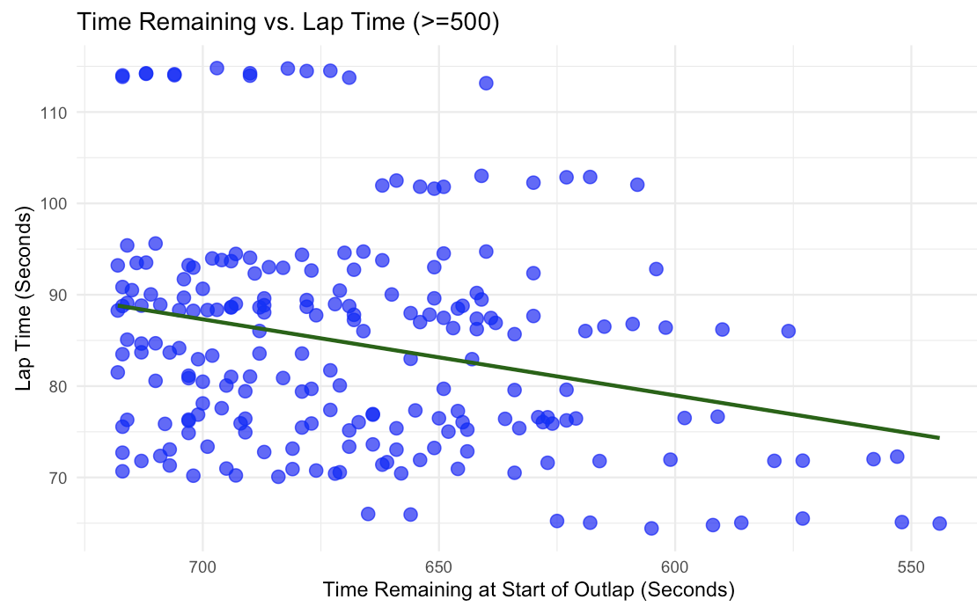

Figure 1 shows a scatterplot of time remaining at the start of a driver’s out lap against that driver’s resulting hot lap time (both in seconds), specifically including only observations where the start of the out lap occurred with greater than or equal to 500 seconds remaining in the qualifying session.

***Figure 2*:**

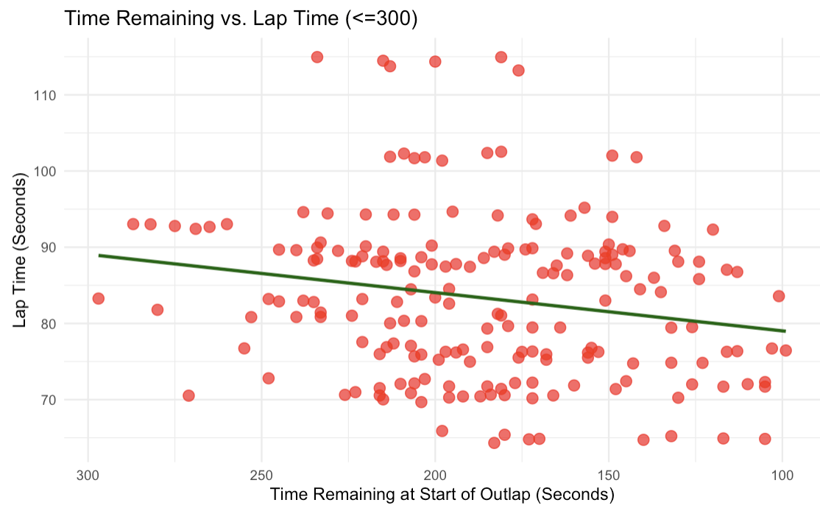

Figure 2 shows a scatterplot of time remaining at the start of a driver’s out lap against that driver’s resulting hot lap time (both in seconds), specifically including only observations where the start of the out lap occurred with less than or equal to 300 seconds remaining in the qualifying session.

***Figure 3*:**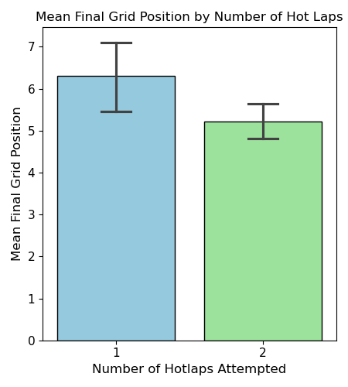

Figure 3 shows a bar plot of the mean final grid position for drivers who attempted one hot lap versus two hot laps during Q3 qualifying sessions, along with 95 percent confidence intervals for the true mean final grid position of each group. The figure shows that, while drivers who attempted two hot laps appear to qualify better on average, the 95 percent confidence intervals for the two groups overlap slightly. This visual overlap suggests that the observed difference might not be statistically significant. We proceed with a formal investigation of this relationship in the following section.

**INSIGHTS FROM THE DATA**

*Insight 1.1: One vs. Two Hot Laps*

In collecting data on each final qualifying session across the 2024 Formula 1 season, we sought to analyze how decisions made during each session impacted drivers’ starting grid position on the day of the real competition. In other words, we hoped to identify actionable insights that can be interpreted and implemented by Formula 1 drivers, coaches, and teams to place higher in individual races and earn more points towards a championship title. One strategic decision teams must make during this qualifying session is whether to have their driver attempt one hot lap or two. Attempting two hot laps can provide an opportunity to improve upon a first attempt, especially if track conditions evolve or if a driver makes a small mistake. However, it also carries risks, such as tire degradation or unfavorable track traffic.

As seen in Figure 3, the two groups’ 95 percent confidence intervals for mean final grid position overlap, so there may not be a statistically significant difference in performance between drivers who attempt one hot lap versus two hot laps in a qualifying session. To further explore the effects of one versus two hot lap strategies, we first summarized the number of hot laps attempted by each driver in each session. This was carried out in the Python programming language using the *pandas* function *groupby* on our original dataset. The result was a *pandas* series that stored the number of hot laps attempted by each driver in each of the 24 qualifying sessions. The series, indexed by the date of the session and the name of the driver, contained 235 unique date-driver pairings. 185 pairings (approximately 78.7 percent) were associated with two hot laps, and 46 (approximately 19.6 percent) were associated with one hot lap. Since a large majority of drivers elected to make two hot lap attempts as opposed to one throughout the qualifying sessions, we then chose to investigate whether drivers attempting two hot laps consistently achieved better final grid positions compared to those making only a single attempt.

Because each qualifying session can differ in ways that might affect all drivers, such as track evolution, weather conditions, or overall competitiveness, we needed a modeling approach that would control for these session-specific factors. To achieve this, we utilized a fixed-effects linear regression model, which accounts for unobserved differences between sessions by estimating a separate intercept for each qualifying event. The model was fit using the *ols* function from Python’s *statsmodels.formula.api* interface, specifying final grid position as a function of the number of hot laps attempted and a set of session-specific categorical variables. This approach allowed us to isolate the effect of attempting one versus two hot laps on a driver's final grid position while holding constant the unique conditions of each session. Mathematically, the fixed-effects regression model is represented by the following function:

${\hat{y}}_{i,t}=β_{0}+β_{1}x_{i,t}+α_{t}+ϵ_{i,t}$,

where *ŷi,t* represents the predicted grid position for driver *i* in session *t*, *xi,t*is an indicator variable equal to one if the driver attempted two hot laps and zero otherwise, 𝛽0 is the baseline intercept, 𝛽1 captures the average effect of attempting two hot laps, 𝛼t represents a session-specific fixed effect to control for unobserved heterogeneity across qualifying sessions, and 𝜖*i,t*is the random error term. This model removes all time-invariant differences across sessions by including session fixed effects, ensuring that comparisons between one- and two-hotlap drivers are made strictly within the same qualifying event rather than across different race weekends.

Before interpreting the results of the fixed-effects regression model, we assessed whether the underlying assumptions of linear regression were reasonably satisfied. These assumptions include linearity, independence of residuals, homoscedasticity (constant variance of residuals), and normality of residuals. To evaluate linearity and homoscedasticity, we plotted the residuals against the fitted values using the *seaborn* package's *scatterplot* function in Python. The plot showed that the residuals were generally centered around zero, with no clear curvature, suggesting that the relationship between the predictors and grid position was approximately linear. While there was a slight widening of the residual spread at extreme fitted values, indicating mild heteroscedasticity, this pattern was not severe enough to materially affect the interpretation of the model. Normality of residuals was assessed by examining both a histogram and a quantile-quantile (QQ) plot. The histogram, generated using *seaborn*’s *histplot* function, displayed an approximately symmetric, bell-shaped distribution. The QQ plot, created with the *scipy.stats* package, showed residuals falling close to the 45-degree reference line, with minor deviations at the tails. These results indicate that the residuals were reasonably normally distributed. Finally, to assess independence of residuals, we calculated the Durbin-Watson statistic, which returned a value of 2.252. Since a value close to two suggests little to no autocorrelation, we concluded that the residuals were independent. Overall, while minor deviations from ideal assumptions were present, the fixed-effects regression model satisfied the core assumptions of linear regression sufficiently to proceed with interpreting the results.

The fixed-effects regression model estimated a baseline intercept (𝛽0) of 7.1973, which represents the average final grid position for drivers who attempted only one hot lap, after controlling for differences across qualifying sessions. The average effect of attempting two hot laps (𝛽1) was estimated at -1.8858, with a p-value of 0.002 and a 95 percent confidence interval of [-3.047, -0.725]. This negative and statistically significant coefficient indicates that, after accounting for session-specific effects, drivers who attempted two hot laps qualified on average approximately 1.89 grid positions higher than those who attempted only one hot lap. The p-value of 0.002 provides strong evidence to reject the null hypothesis of no difference in final grid position between one and two hot lap attempts, and the confidence interval suggests that the true effect is likely between approximately 0.73 and 3.05 grid positions better for two hot lap drivers. These results support the conclusion that attempting two hot laps during the final qualifying session provides a measurable competitive advantage in securing a better starting position for the race.

*Insight 1.2: Optimal Track Entry Time*

Another strategic decision teams make regarding track entry throughout the session is when to send a driver onto the track. Due to the extremely slim margins separating drivers' lap times, this decision can have consequential effects for numerous reasons. Track entry time determines the track position of that driver, with each track position experiencing slightly different track conditions, air conditions, as well as having access to different information. When more drivers have completed laps on the track, this raises the track temperature, which leads to faster track times but can also lead to increased tire degradation. Depending on track position, a driver can experience either clean air, dirty air, or a tow. Clean air occurs when a driver completes a lap with no driver in front of them, or with sufficient space between them and the driver ahead of them on track. This allows for predictable air conditions and more consistent laps. When a driver races too closely behind another driver, dirty air can occur. This causes air flow to be disrupted and not hit the aerodynamic components of the car, decreasing effectiveness. However, when spaced correctly, racing behind a driver can decrease air resistance, increasing speed. These are only some of the nuanced differences in a lap that track position can lead to. Because of this, the time at which a driver begins their out lap is a crucial decision for a team. To examine this, we first examined the distribution of the variable *`Time Remaining in session at Start of Outlap (Seconds)`,* which we will refer to as TRS. Measured in seconds, TRS tells us how much time was left in the qualifying session when the driver went out onto the track. The following histogram shows this distribution:

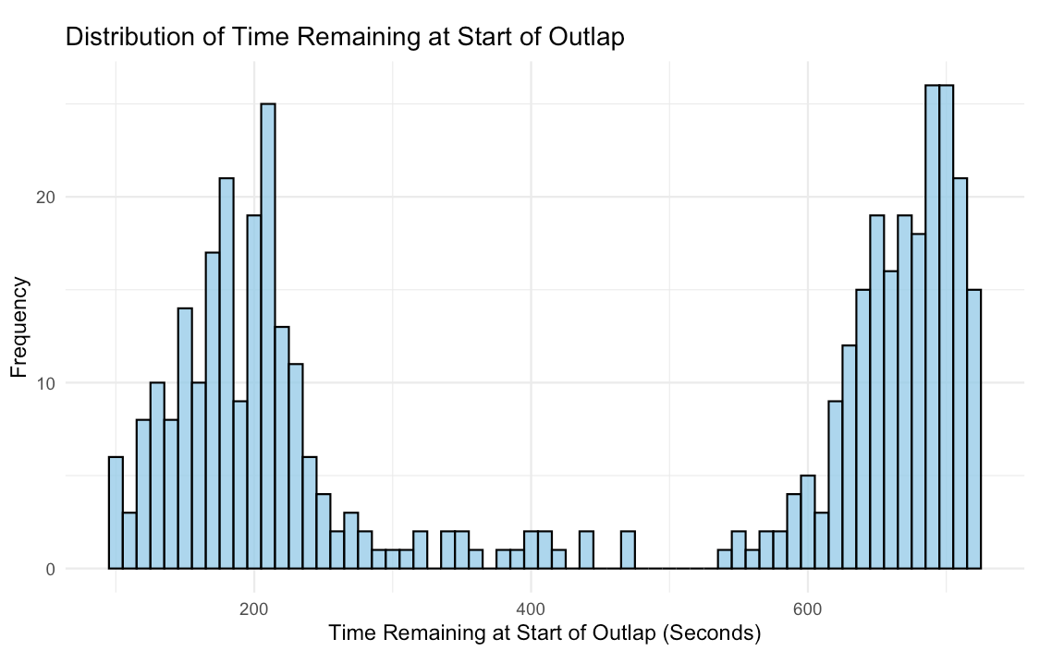

As previously discussed, drivers typically go out on track twice during the qualifying session, with most entries onto the track concentrated around 700 seconds remaining and 200 seconds remaining. The time interval between 300 and 500 seconds is made up of almost exclusively drivers only attempting one hot lap in the session. To focus on drivers who attempt two hot laps, the original dataset was split into two subsets using the *filter* function in R; one with hot laps when TRS was greater than or equal to 500, and one where TRS was less than or equal to 300. Figures 1 and 2 in the ‘Summary of the Data’ section show the correlation between TRS and Lap Time.

In both graphs, a downward trend is present, suggesting that going out later in the session leads to a faster lap time. However, this correlation fails to account for differences in track length, with longer tracks always posting longer race times regardless of TRS. To account for this, we created a new standardized lap time variable. First, we used the *groupby* function in R to group results by Race. We then used the *mutate* function to perform the following transformation for each lap *i* at Race *j*:

*Standardized Lap = (Lap_Timeij - Mean_Lap_Timej) / Standard_Deviation_Lapj*

By standardizing each lap time, we can now see how many standard deviations faster or slower a lap is, compared to the average lap time at each track, effectively controlling for track differences. The following two graphs show the new correlation between TRS and Standardized lap time for each subset of the data.

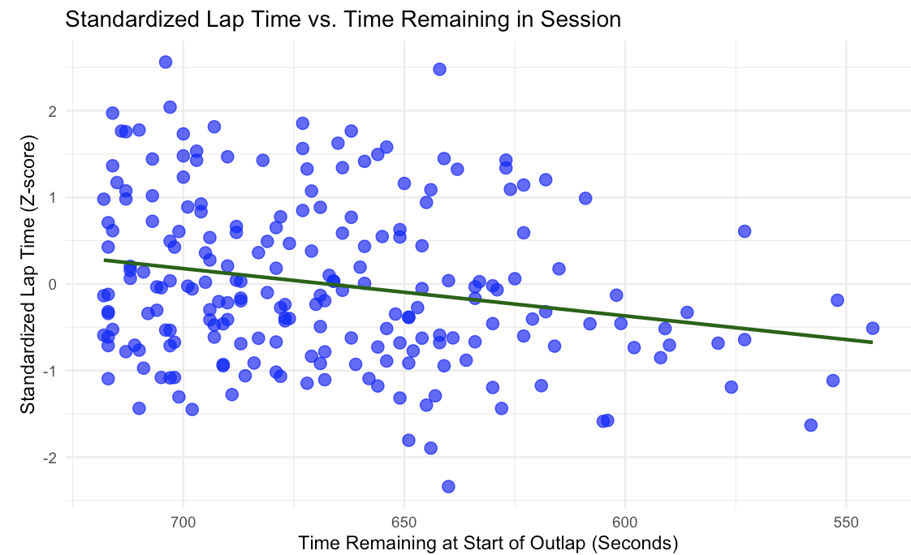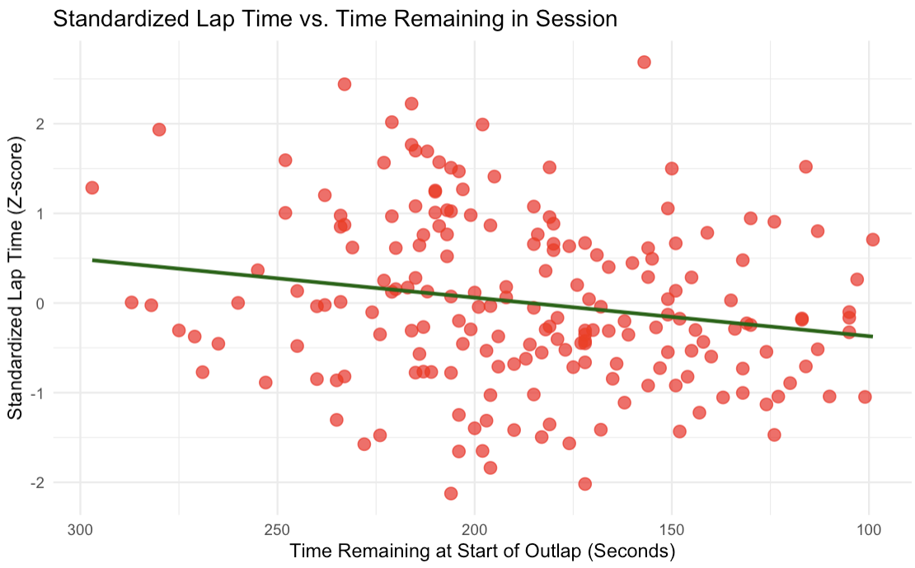

The new standardized lap time allows one to see a clearer correlation between TRS and Lap time, with both graphs again showing a downward sloping trend.

To examine the effect of the TRS variable on Standardized Lap Time, an ordinary least squares (OLS) linear regression was fitted. To control for the possibility that faster teams consistently went out later in the session, we added fixed effects to the model for each team. A model was built for both subsets of the original data. ‘Model 1’ will be used to reference the subset of data with Time Remaining in the Session greater than or equal to 500, and ‘Model 2’ will be used to reference the data with TRS less than or equal to 300. Both fixed effects models were built using the *lm* function in R, and are mathematically represented by the following formula:

${\hat{y}}_{i}=β_{0}+β_{1}x_{i}+α_{t}+ϵ_{i}$,

where *ŷi* represents the predicted Standardized Lap Time, *xi* is the time remaining in the session at the start of the out lap for observation *i,* 𝛼*t* is the fixed effect for the team that observation *i* belongs to, and 𝜖*i* is the error term. 𝛽0 is the baseline predicted Standardized Lap time, and 𝛽1 captures the average change in predicted Standardized Lap time as TRS increases by one second. This means that a positive value for 𝛽1 suggests that Lap Time improves as the time remaining in the session decreases.

As done previously, we assessed whether the underlying assumptions of linear regression were satisfied. This was done using the *par* function in R to generate a QQ plot and a plot of the residuals against fitted values. The QQ plot for both models showed little departure from the 45-degree reference line, and the plot of residuals against fitted values for both models showed that the residuals were normally distributed around zero. This demonstrates that the residuals are reasonably normally distributed and that the relationship between Standardized Lap Time and TRS is linear.

***Model 1:***

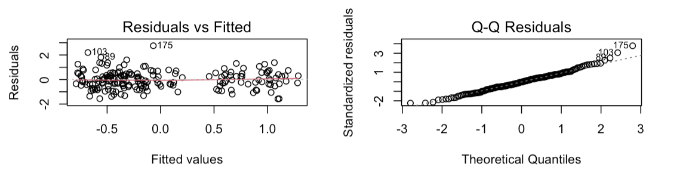

***Model 2:***

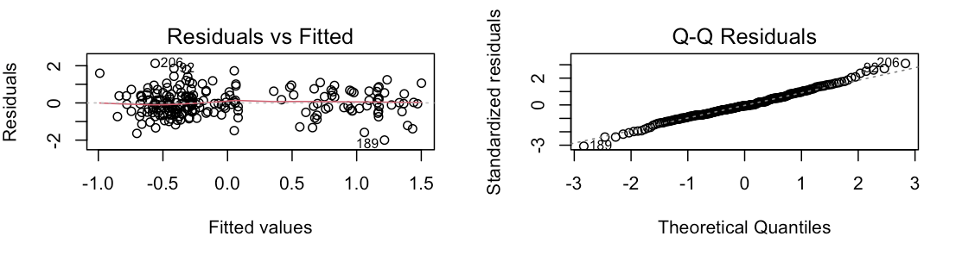

Finally, the Durbin-Watson statistic was calculated for both models using the *dwtest* function from the *lmtest* package in R. Model 1 returned a value of 2.0072, showing no auto-correlation, and Model 2 returned a value of 1.8272 with a p-value of 0.0922, showing that the slightly positive auto-correlation was not statistically significant. These plots and tests confirm that the linear regressions satisfy the necessary assumptions.

The estimated Model 1 had a 𝛽1 value of 0.004288 with a corresponding p-value of 0.000966. This coefficient value can be interpreted as a one second increase in Time Remaining in Session leading to an increase in Predicted Standardized Lap time by 0.004288 standard deviations. In other words, starting a driver’s out lap one second later improves their Predicted Standardized lap time by 0.004288 standard deviations. With a p-value of 0.000966, 𝛽1 is statistically significant at the 95 percent confidence level. The estimated Model 2 fit on the data subset looking at out laps with TRS less than or equal to 300 had a 𝛽1 value of 0.002768 with a p-value of 0.04934. Once again, the positive 𝛽1 value suggests that starting a driver’s out lap one second later improves their Predicted Standardized lap time by 0.002768 standard deviations on average. With a p-value of 0.04934, the 𝛽1 value is statistically significant.

These results strongly support the conclusion that starting the initial out lap later on in the qualifying session, for both the first and second attempted hot laps, significantly improves lap times. Knowing that attempting two hot laps is better than attempting one, we can draw the insight that teams should do their best to delay their out lap start time while allowing a window for two out laps to be completed. As discussed before, this could be due to a multitude of reasons, such as improved track temperature, lessened air resistance, and more time to gather intel after seeing other drivers race on the track.

*Insight 2: Sector 2 Significance*

Although every part of an F1 lap is vital during a qualifying session, data from the 2024 Q3 qualifying sessions reveals a more nuanced picture: Sectors 1 and 3 are consistently more predictive of hot lap performance, while Sector 2's influence is often diminished and highly dependent on track layout. Using per-race linear regression models (Figure 4), we found that Sector 1 had the highest average coefficient (1.055), followed closely by Sector 3 (1.022), while Sector 2 trailed behind (0.945). Statistically, Sector 2 was not significant in nearly 10% of races, while Sectors 1 and 3 were significant in 100% of Q3 sessions (Table 3). These differences are not coincidental: they reflect underlying insights about how qualifying laps are executed, how tracks are designed, and where drivers have the room to gain or lose critical time.

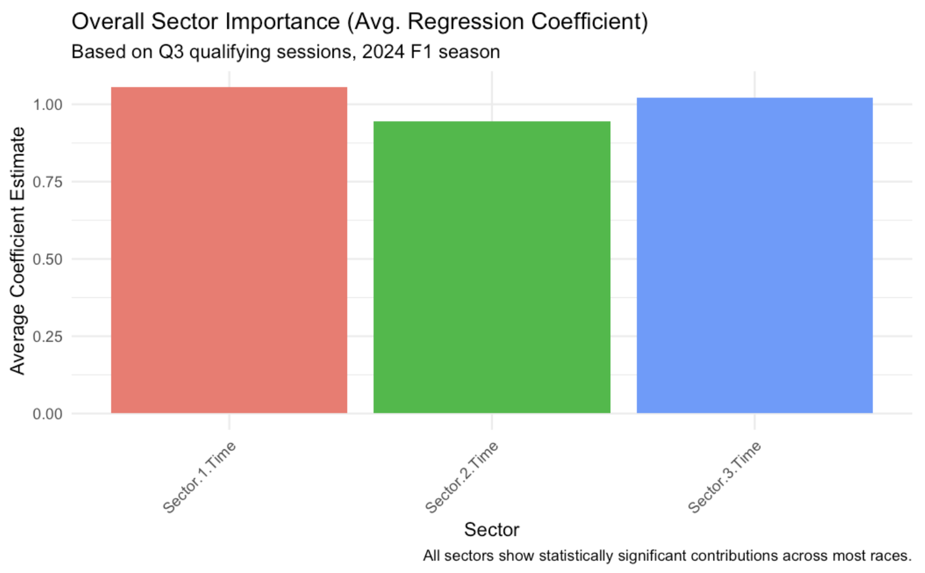

***Figure 4.*** *Barplot showing the average regression coefficient estimates for Sector 1, Sector 2, and Sector 3 times, based on Q3 qualifying sessions during the*

*2024 Formula 1 season. Sector 1 and Sector 3 times exhibited higher predictive importance for overall lap performance compared to Sector 2.*

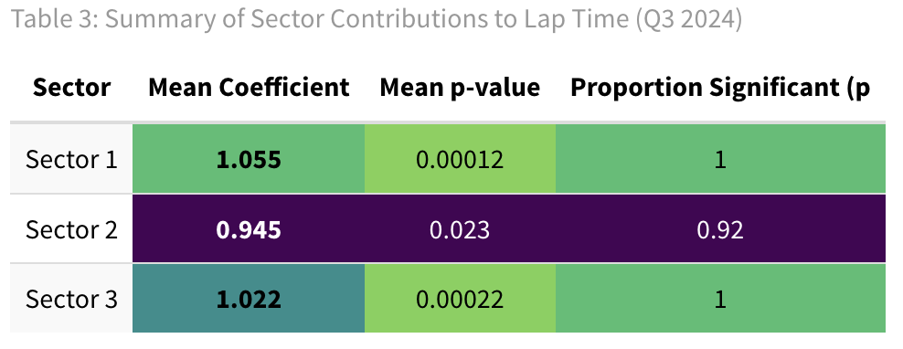

To better understand why Sector 2 might be less statistically significant, we compared weather conditions and average lap lengths between races where Sector 2 was significant versus insignificant. Surprisingly, there were no meaningful insights to draw from this comparison: the two races where sector 2 times were insignificant had clear weather, and the average lap times were statistically indistinguishable. This ruled out the idea that Sector 2 was simply less important in longer or weather-affected races. Instead, a deeper dive into the performance variability revealed the answer. I isolated the two races where Sector 2 was not statistically significant — the Saudi Arabian Grand Prix (Jeddah) and the Spanish Grand Prix (Barcelona) — and found that both had an extremely low standard deviation in Sector 2 times (Table 4). This lack of variability rendered Sector 2 statistically irrelevant in our regression models. From a statistical standpoint, low variance means low explanatory power, and from a racing standpoint, it suggests that all drivers were performing at a very similar level in that sector.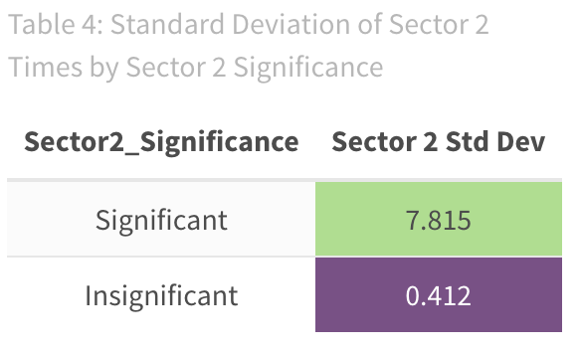

That observation led to a circuit-level analysis. Jeddah’s Sector 2 is a flat-out, high-speed stretch with few braking zones (turns) — drivers are essentially full throttle and have little room for creative racing lines. Barcelona’s Sector 2 comprises a series of medium-speed, flowing corners where drivers aim to maintain momentum rather than aggressively brake or accelerate. Unlike other sectors that include heavy braking zones or tight turns where driver skill can create big lap time differences, this sector offers very few opportunities for variation. Everyone takes a similar racing line, and the time gained or lost here depends less on the driver’s risk-taking and more on the car’s aerodynamic performance and balance. In both cases, the sector creates a situation where driver behavior converges — they all do roughly the same thing at the same performance level. This explains why Sector 2's statistical contribution drops in these specific cases. In contrast, Sectors 1 and 3 consistently offer greater opportunities for performance differentiation. Sector 1 often opens with heavy braking and complex entry zones that challenge the driver’s ability to execute with precision, mental sharpness, and optimal out lap preparation. Errors or excellence in this phase can define the trajectory of the entire lap. Sector 3, meanwhile, tends to include tight corners and key exit points onto the main straight, demanding composure, rear-end stability, and tire management at the tail end of the lap. These dynamics make Sectors 1 and 3 not only more volatile but also more driver-dependent, which is exactly why they show higher coefficients and extreme statistical significance in our models.

In summary, this insight reveals that while all sectors matter, their impact is not uniform, and more importantly, it's not always obvious from intuition alone. Sector 2’s influence is highly conditional on the design and variability of the track, not external factors like weather or race distance. Teams and drivers aiming for optimal qualifying strategy should recognize that Sectors 1 and 3 offer more consistent opportunities for time gain, and prepare their cars and drivers accordingly to attack those zones where variability, and thus opportunity, is greatest.

*Limitations and critiques*

One of the specific areas we explored was whether attempting two hot laps improved final grid position compared to attempting only one. While our analysis showed a statistically significant advantage for drivers who attempted two hot laps, there are several aspects of this part of the study that could be improved. First, we only considered the number of hot laps attempted as the independent variable when fitting the fixed-effects linear regression. Other factors that might influence a driver’s decision to attempt a second lap, such as an inherently faster pace, better tire management, or greater confidence in one’s setup, were not accounted for. Additionally, we did not obtain data on tire condition or lap preparation strategies, both of which could substantially affect a driver’s ability to improve on a second attempt. Including variables such as tire age, out lap timing relative to track evolution, and even further measures of first lap performance would allow for a richer, more controlled model. Finally, while fixed effects helped control for differences across sessions, they could not account for within-session changes such as sudden weather shifts or localized traffic, which might disproportionately affect the success of a second lap. Future studies incorporating these additional factors could provide a clear understanding of when attempting a second hot lap is truly advantageous.

As part of determining how many times a driver should attempt a hot lap, we also examined when a driver should complete these outlaps. We were able to find a statistically significant result that suggested drivers should go out on track later in the session, however, a major limitation was that we could not address why this was the case with the data we had available. There are many possible explanations, but understanding what exactly was causing the lap improvement would be crucial for teams to maximize results. One variable we could have collected would have been Time Remaining in Session at Start of Hot Lap, as opposed to the start of Out Lap. Because drivers' out laps often vary highly in length, we did not have information on how close a driver was to another driver on track during their hot lap. This would have been helpful to determine how track position and spacing were affecting lap times.

For our second insight, while the analysis provided strong evidence that low variance in Sector 2 times at certain tracks (specifically Jeddah and Barcelona) explained its reduced statistical significance, there are several important limitations to this study. First, the model only considered sector times and lap length, without accounting for potential confounding factors such as specific car setup differences or track evolution during the qualifying session. Both of these factors could influence how much variability drivers experience within a sector. Additionally, while weather conditions were checked broadly, more precise weather metrics like track surface temperature at the time of the hot lap, wind gusts, or humidity could have added nuance to the analysis. These could have helped explain differences in how consistent or inconsistent drivers were through Sector 2 at specific events.

Another limitation is that we used linear regression, assuming independent sector contributions to lap time, but in reality, driver performance across sectors is likely correlated: a mistake early in the lap (in Sector 1) could subtly impact speed and tire condition in Sector 2. The regression model does not account for these chained effects. Finally, our classification of Sector 2 significance was based solely on p-values from race-by-race regressions, but with relatively small sample sizes in each session (only 10 drivers), a larger dataset combining multiple seasons, or modeling across more laps (such as Q1 and Q2 runs) could have given more reliable statistical conclusions. These additional variables and methods would have strengthened the conclusions and helped isolate the specific reasons for low Sector 2 variance more precisely.

**WORKS CITED**

Elshebiny, Yara. “F1 Explained: What is an out lap, a hot lap and an in lap?” *GPFans*, 15 May 2024, https://www.gpfans.com/en/f1-news/1020322/f1-what-is-an-out-lap-explained/. Accessed 23 April 2025.

“Everything you need to know about F1 – Drivers, teams, cars, circuits and more | Formula 1®.” *F1*, https://www.formula1.com/en/latest/article/drivers-teams-cars-circuits-and-more-everything-you-need-to-know-about.7iQfL3Rivf1comzdqV5jwc. Accessed 23 April 2025.

“F1 Terminology.” *Miami Grand Prix*, https://f1miamigp.com/formula-1-terminology/. Accessed 23 April 2025.

Spolaor, Valentina. *The Importance of Strategy in Formula One Race Outcomes and the Impact of Regulatory Changes in the Competitive Balance of the Sport*, 2022, https://hdl.handle.net/20.500.14247/8877.